**MOBILE APPLICATIONS LAB 7**

**CREATE A MENU APPLICATION**

**NAME: LENA GEO**

**REGISTER NUMBER: 2241139**

**Code:**

**MainActivity.kt**

package com.example.lab7  
  
import android.content.Intent  
import android.os.Bundle  
import android.view.ContextMenu  
import android.view.Menu  
import android.view.MenuItem  
import android.view.View  
import android.widget.Button  
import android.widget.PopupMenu  
import android.widget.TextView  
import android.widget.Toast  
import androidx.appcompat.app.AppCompatActivity  
  
class MainActivity : AppCompatActivity() {  
  
 override fun onCreate(savedInstanceState: Bundle?) {  
 super.onCreate(savedInstanceState)  
 setContentView(R.layout.*activity_main*)  
  
 // Popup Menu Button  
 val actionButton = findViewById<Button>(R.id.*action_button*)  
 actionButton.setOnClickListener { showPopup(it) }  
  
 // Context Menu TextView  
 val longPressTextView = findViewById<TextView>(R.id.*long_press_text*)  
 registerForContextMenu(longPressTextView)  
 }  
  
 // Create Options Menu  
 override fun onCreateOptionsMenu(menu: Menu?): Boolean {  
 *menuInflater*.inflate(R.menu.*options_menu*, menu)  
 return true  
 }  
  
 // Handle Options Menu Item Selection  
 override fun onOptionsItemSelected(item: MenuItem): Boolean {  
 return when (item.*itemId*) {  
 R.id.*action_profile* -> {  
 startActivity(Intent(this, ProfileActivity::class.*java*))  
 true  
 }  
 R.id.*action_settings* -> {  
 startActivity(Intent(this, SettingsActivity::class.*java*))  
 true  
 }  
 R.id.*action_about* -> {  
 startActivity(Intent(this, AboutActivity::class.*java*))  
 true  
 }  
 R.id.*action_help* -> {  
 startActivity(Intent(this, HelpActivity::class.*java*))  
 true  
 }  
 R.id.*action_feedback* -> {  
 startActivity(Intent(this, FeedbackActivity::class.*java*))  
 true  
 }  
 else -> super.onOptionsItemSelected(item)  
 }  
 }  
  
 // Show Popup Menu  
 private fun showPopup(view: View) {  
 val popupMenu = PopupMenu(this, view)  
 popupMenu.inflate(R.menu.*popup_menu*)  
  
 popupMenu.setOnMenuItemClickListener { menuItem: MenuItem ->  
 when (menuItem.*itemId*) {  
 R.id.*action_edit* -> {  
 Toast.makeText(this, "Edit clicked", Toast.*LENGTH_SHORT*).show()  
 true  
 }  
 R.id.*action_delete* -> {  
 Toast.makeText(this, "Delete clicked", Toast.*LENGTH_SHORT*).show()  
 true  
 }  
 R.id.*action_share* -> {  
 Toast.makeText(this, "Share clicked", Toast.*LENGTH_SHORT*).show()  
 true  
 }  
 else -> false  
 }  
 }  
 popupMenu.show()  
 }  
  
 // Create Context Menu for Long Press on TextView  
 override fun onCreateContextMenu(menu: ContextMenu?, v: View?, menuInfo: ContextMenu.ContextMenuInfo?) {  
 super.onCreateContextMenu(menu, v, menuInfo)  
 *menuInflater*.inflate(R.menu.*context_menu*, menu)  
 }  
  
 // Handle Context Menu Item Selection and link to respective activities  
 override fun onContextItemSelected(item: MenuItem): Boolean {  
 return when (item.*itemId*) {  
 R.id.*action_copy* -> {  
 startActivity(Intent(this, ProfileActivity::class.*java*)) // Link to ProfileActivity  
 true  
 }  
 R.id.*action_paste* -> {  
 startActivity(Intent(this, SettingsActivity::class.*java*)) // Link to SettingsActivity  
 true  
 }  
 R.id.*action_cut* -> {  
 startActivity(Intent(this, AboutActivity::class.*java*)) // Link to AboutActivity  
 true  
 }  
 else -> super.onContextItemSelected(item)  
 }  
 }  
}

**options_menu.xml**

<?xml version="1.0" encoding="utf-8"?>  
<menu xmlns:android="http://schemas.android.com/apk/res/android">  
  
 <group>  
 <item  
 android:id="@+id/action_profile"  
 android:title="Profile" />  
 <item  
 android:id="@+id/action_settings"  
 android:title="Settings" />  
 </group>  
 <group>  
 <item  
 android:id="@+id/action_about"  
 android:title="About" />  
 <item  
 android:id="@+id/action_help"  
 android:title="Help" />  
 <item  
 android:id="@+id/action_feedback"  
 android:title="Feedback" />  
 </group>  
  
</menu>

**context_menu.xml**

<?xml version="1.0" encoding="utf-8"?>  
<menu xmlns:android="http://schemas.android.com/apk/res/android">  
 <item  
 android:id="@+id/action_copy"  
 android:title="Copy" />  
 <item  
 android:id="@+id/action_paste"  
 android:title="Paste" />  
 <item  
 android:id="@+id/action_cut"  
 android:title="Cut" />  
</menu>

**popup_menu.xml**

<?xml version="1.0" encoding="utf-8"?>  
<menu xmlns:android="http://schemas.android.com/apk/res/android">  
 <item  
 android:id="@+id/action_edit"  
 android:title="Edit" />  
 <item  
 android:id="@+id/action_delete"  
 android:title="Delete" />  
 <item  
 android:id="@+id/action_share"  
 android:title="Share" />  
</menu>

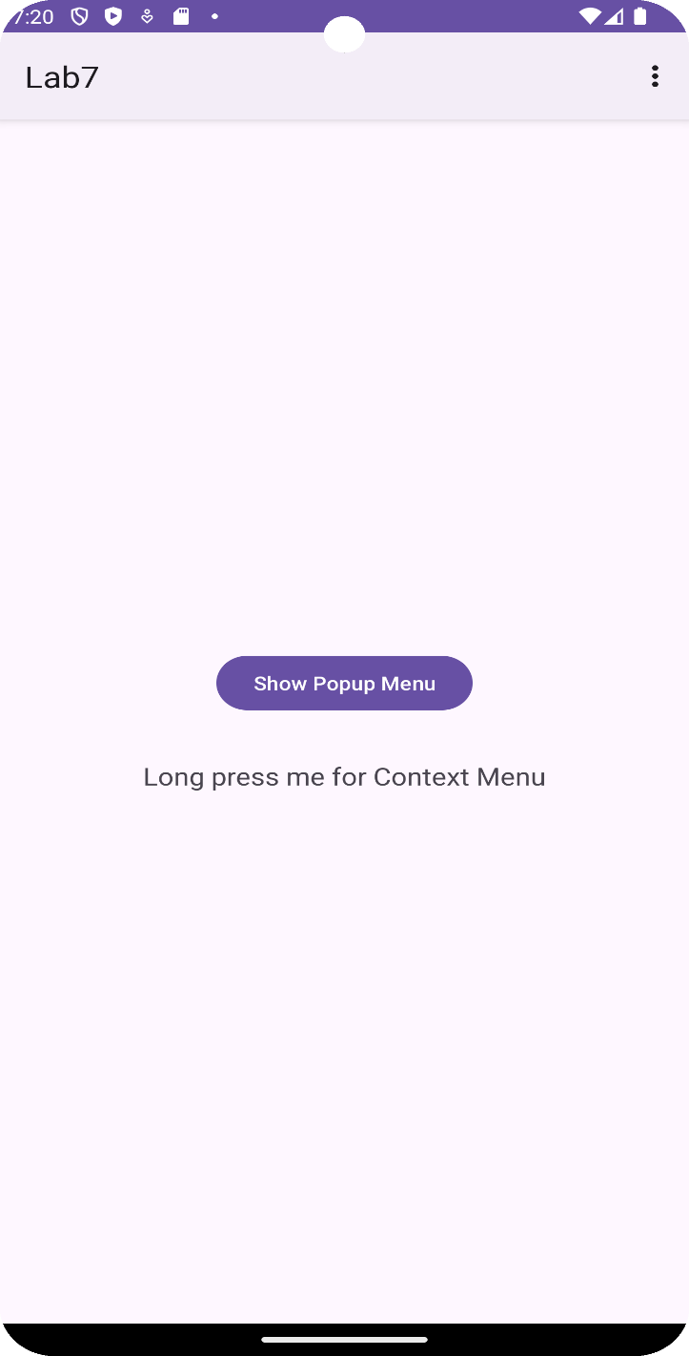**OUTPUT**

